Gen-HRES: Conditional Adversarial Network (cGAN) Training using Torch & Pandas in Python

1. Data Sourcing
1.1. Overview
The Gen-HRES project uses meteorological data gotten from the NASA POWER API (Prediction Of Worldwide Energy Resources). This API provides us with satellite-derived, model-assimilated datasets specifically tailored for renewable energy, building energy efficiency, and agricultural applications. The data fetching logic is implemented in the fetch_nasa_power.py file.
Property | Detail
API Endpoint | https://power.larc.nasa.gov/api/temporal/hourly/point
Resolution | Hourly (1H)
Range | Jan 1, 2015 – Dec 31, 2025
Output Format | CSV

Three meteorological parameters are fetched for both locations:
Paramter | Description | Unit
ALLSKY_SFC_SW_DWN | Surface Shortwave Downward Irradiance | W/m²
WS50M | Wind Speed at 50 Meters Above Ground | m/s
T2M | Temperature at 2 Meters Above Ground | °C
These three variables were chosen because they are the primary drivers for hybrid renewable energy system (HRES) modelling — capturing solar generation potential, wind generation potential, and thermal operating conditions simultaneously.

1.2. Geographic Locations
The data is sourced for two geographic locations within Nigeria but representing distinct climate zones:
City | Lattitude | Longitude | Characteristic
Lagos | 6.5244 °N | 3.3792 °E | Southern coastal tropical with more cloud cover and higher humidity
Kano | 12.0022°N | 8.5920°E | Semi-arid (Sahel) with higher solar irradiance and lower humidity
By selecting both Kano and Lagos, the dataset captures a meaningful range of Nigerian weather conditions across regions from the dry, high-irradiance Sahel environment in Kano State to the humid, more cloud-prone coastal areas of Lagos.

1.3. Data Acquisition Process
1.3.1. Preflight Check
Before making any API calls, the script checks whether data files already exist in the nasa_power_data/ directory. If all expected files are present, the script exits early to avoid redundant downloads.

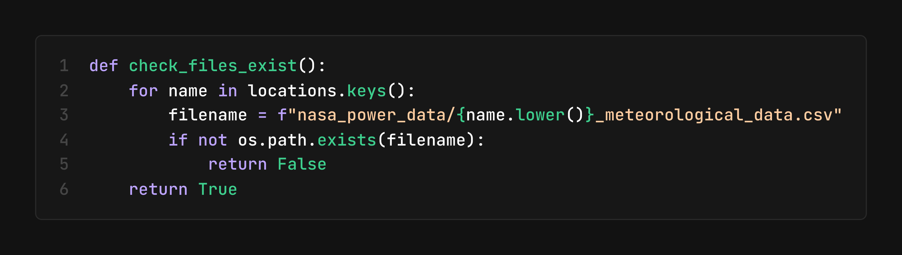
1.3.2. API Request Construction
For each location, an GET request is performed to return meteorological data and successful responses are written directly to CSV files in the nasa_power_data/ directory:

- nasa_power_data/kano_meteorological_data.csv
- nasa_power_data/lagos_meteorological_data.csv

Each file contains hourly records with columns for Year, Month, Day, Hour, and the three meteorological parameters outlined In the table above.
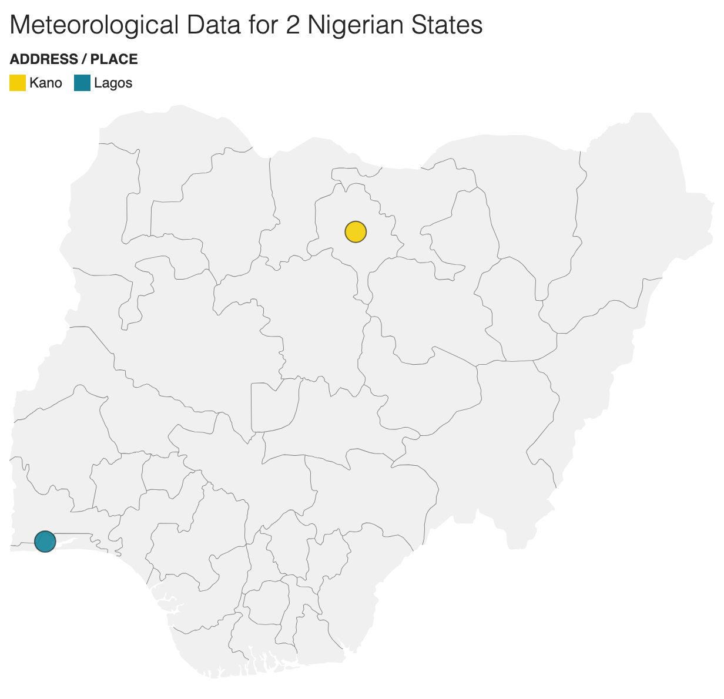
1.3.3. Notes
- The NASA POWER API returns -999.0 as a sentinel value for missing observations. These are handled downstream in the preprocessing stage.
- If the specified end date extends beyond the latest available data, the API returns data up to the most recent available date.
- The script uses a simple early-exit mechanism to prevent re-downloading existing data, making the pipeline idempotent.

2. Preprocessing
The preprocessing pipeline transforms raw NASA POWER CSV data into clean, normalized, and structured arrays ready for GAN training. All logic resides in preprocess_nasa_data.py. The pipeline produces three output artifacts: a long-format CSV, a NumPy array of daily profiles, and a labels CSV.

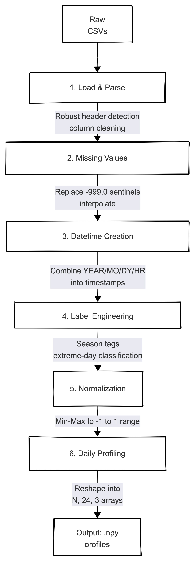
- Loading and Parsing: The resulting CSV files contain metadata headers before the actual data begins. The script robustly locates the header row by scanning for the line containing Year, Month, Day, and Hour.

